**DAILY ONLINE ACTIVITIES SUMMARY**

|  |  |  |  |  |  |  |  |  |
| --- | --- | --- | --- | --- | --- | --- | --- | --- |
| **Date:** | **18/05/202** | | | | | **Name:** | **Anjali Manohar Prabhu** | |
| **Sem & Sec** | **4th Sem Section-“A”** | | | | | **USN:** | **4AL18CS007** | |
| **Online Test Summary** | | | | | | | | |
| **Subject** | | **Complex Analysis, Probability theory and statistics** | | | | | | |
| **Max. Marks** | | **30** | | **Score** | | | **NA** | |
| **Certification Course Summary** | | | | | | | | |
| **Course** | **PYTHON IN MACHINE LEARNING** | | | | | | | |
| **Certificate Provider** | | | 1. **Great Learning Academy** | | **Duration** | | | **1.45min** |
| **Coding Challenges** | | | | | | | | |
| **Problem Statement:** 1. An Anagram of a string is another string that contains same characters, only the order of characters can be different. For example, "act" and "cat" are anagram of each other.  2.Using methods charAt() & length() of String class, write a program to print the frequency of each character in a string. “Hello friend”  Output should be -: 1 d: 1 e: 2 f: 1 | | | | | | | | |
| **Status: Completed** | | | | | | | | |
| **Uploaded the report in Github** | | | | | **Yes** | | | |
| **If yes Repository name** | | | | | **https://github.com/vinisharen/lockdown-coding** | | | |
| **Uploaded the report in slack** | | | | | **Yes** | | | |

Online Test Details: Online test was conducted on the fourth module of math. Test contains 30 questions of 1 mark each

Certification Course Details: Started the course by choosing Python in machine learning course, with basic introduction to Python. It includes what is Python, why Python is important in machine learning

Snapshot: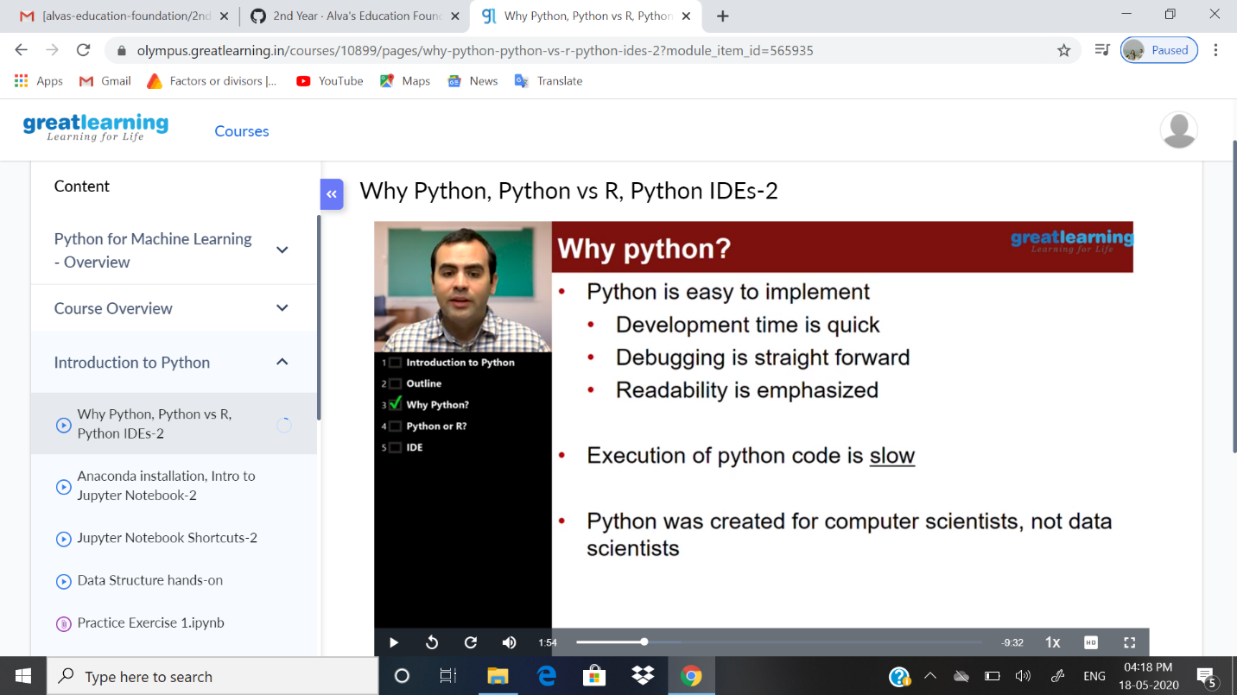

Coding Challenges Details: Problem statements

**:** 1. An Anagram of a string is another string that contains same characters, only the order of characters can be different.  
For example, "act" and "cat" are anagram of each other.

Solution: Uploaded in Github

Snapshot:

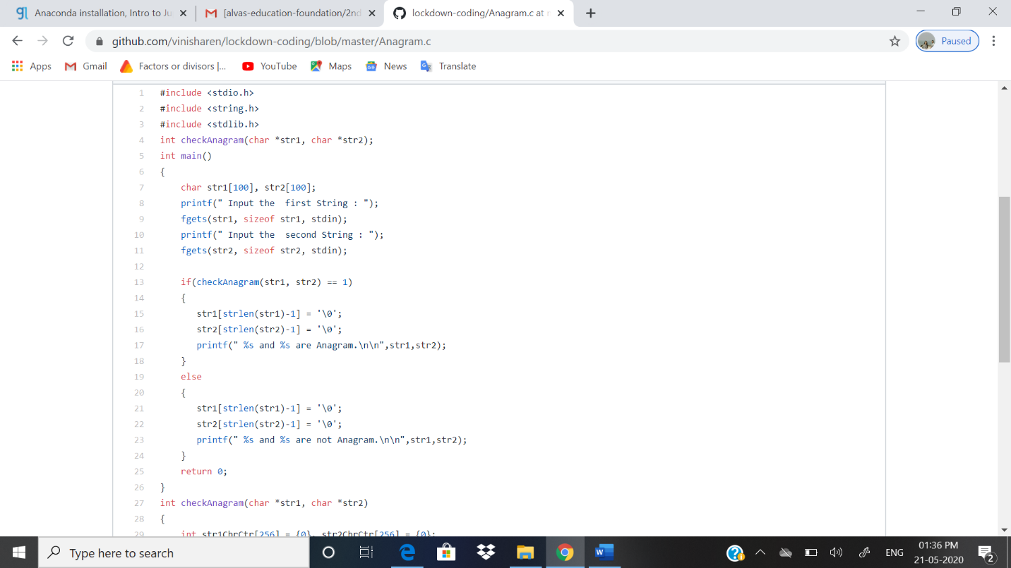

2.Using methods charAt() & length() of String class, write a program to print the  
frequency of each character in a string.  
“Hello friend”

Output should be  
-: 1  
d: 1  
e: 2  
f: 1

Solution: Uploaded in github

Snapshot: